**DESIGN INTERNSHIP (DI-26)**

FOR



**AHB TO APB BRIDGE DESIGN**

**PROJECT REPORT**

DONE BY -

**JAYARAM G**

**MODULE-1 AHB MASTER:**

module ahb_master (input hclk,hresetn, hreadyout, input [31:0] hrdata, input [1:0] hresp,

output reg [31:0] haddr, hwdata, output reg hwrite,hreadyin, output reg [1:0] htrans);

reg [2:0] hburst;

reg [2:0] hsize;

task single_write();

begin

@(posedge hclk);

#1;

begin

hwrite=1;

htrans=2'b10;

hsize=0;

hburst=0;

hreadyin=1;

haddr=32'h8000_0001;

end

@(posedge hclk);

#1;

begin

htrans=2'b00;

hwdata=8'h80;

end

end

endtask

task single_read();

begin

@(posedge hclk);

#1;

begin

hwrite=0;

htrans=2'b10;

hsize=0;

hburst=0;

hreadyin=1;

haddr=32'h8000_0001;

end

@(posedge hclk);

#1;

begin

htrans=2'b00;

end

endendtask

endmodule

**MODULE-2 AHB SLAVE INTERFACE**

module ahb_slave_interface(input hclk,hresetn,hwrite,hready_in, input [1:0] htrans,input [31:0] haddr,hwdata,

output reg valid,hwritereg,hwritereg_1, output [1:0] hresp,output reg [2:0] temp_selx,

output reg [31:0] haddr_1,haddr_2,hwdata_1,hwdata_2, output [31:0] hrdata,input [31:0] prdata);

always @(posedge hclk)

begin

if(!hresetn)

begin

haddr_1<=0;

haddr_2<=0;

end

else

begin

haddr_1<=haddr;

haddr_2<=haddr_1;

end

end

always @(posedge hclk)

begin

if(!hresetn)

begin

hwdata_1<=0;

hwdata_2<=0;

end

else

begin

hwdata_1<=hwdata;

hwdata_2<=hwdata_1;

end

end

always @(posedge hclk)

begin

if(!hresetn)

begin

hwritereg<=0;

hwritereg_1<=0;

end

else

begin

hwritereg<=hwrite;

hwritereg_1<=hwritereg;

end

end

always @(*)

begin

valid=1'b0;

if(hready_in==1 && haddr>=32'h0000_0000 && haddr<32'h8c00_0000 &&

htrans==2'b10||htrans==2'b11)

valid=1;

else

valid=0;

end

always @(*)

begin

temp_selx=3'b000;

if ( haddr>=32'h0000_0000 && haddr<32'h8400_0000)

temp_selx=3'b001;

if ( haddr>=32'h8400_0000 && haddr<32'h8800_0000)

temp_selx=3'b010;

if ( haddr>=32'h8800_0000 && haddr<=32'h8c00_0000)

temp_selx=3'b000;

end

assign hrdata=prdata;

assign hresp=2'b0;

endmodule

**MODULE-3 APB CONTROLLER**

module apb_controller (input hclk,hresetn,hwrite_reg,hwrite,valid,

input [31:0]haddr,hwdata,hwdata1,hwdata2,haddr1,haddr2,pr_data,

input [2:0] temp_selx,

output reg penable, pwrite,

output reg hr_readyout,

output reg [2:0] psel,

output reg [31:0] paddr,pwdata);

parameter ST_IDLE=3'b000,

ST_READ=3'b001,

ST_RENABLE=3'b010,

ST_WWAIT=3'b011,

ST_WRITE=3'b100,

ST_WRITEP=3'b101,

ST_WENABLE=3'b110,

ST_WENABLEP=3'b111;

reg [2:0] PS,NS;

always @(posedge hclk)

begin

if (!hresetn)

PS<=ST_IDLE;

else

PS<=NS;

end

always @(*)

begin

NS=ST_IDLE;

case(PS)

ST_IDLE :

if(valid==1&&hwrite==1)

NS=ST_WWAIT;

else if(valid==1&&hwrite==0)

NS=ST_READ;

else if(valid==0)

NS=ST_IDLE;

ST_READ: NS=ST_RENABLE;

ST_RENABLE:

if(valid==1&&hwrite==1)

NS=ST_WWAIT;

else if(valid==1&&hwrite==0)

NS=ST_READ;

else if(valid==0)

NS=ST_IDLE;

ST_WWAIT:

if (valid==1)

NS=ST_WRITEP;

else if(valid==0)

NS=ST_WRITE;

ST_WRITE:

if (valid==1)

NS=ST_WENABLEP;

else if(valid==0)

NS=ST_WENABLE;

ST_WRITEP: NS=ST_WENABLEP;

ST_WENABLEP:

if (valid==1&&hwrite_reg==1)

NS=ST_WRITEP;

else if (valid==0&&hwrite_reg==1)

NS=ST_WRITE;

else if(hwrite_reg==0)

NS=ST_READ;

ST_WENABLE:

if (valid==1 && hwrite==1)

NS=ST_WWAIT;

else if (valid==1 && hwrite==0)

NS=ST_READ;

else

NS=ST_IDLE;

endcase

end

reg penable_temp,pwrite_temp,hr_readyout_temp;

reg [2:0] psel_temp;

reg [31:0] paddr_temp,pwdata_temp;

always @(*)

begin

case(PS)

ST_IDLE: begin

if(valid==1&&hwrite==0)

begin

paddr_temp=haddr;

pwrite_temp=hwrite;

psel_temp=temp_selx;

penable_temp=0;

hr_readyout_temp=0;

end

else if(valid==1&&hwrite==1)

begin

psel_temp=0;

penable_temp=0;

hr_readyout_temp=1;

end

else

begin

psel_temp=0;

penable_temp=0;

hr_readyout_temp=1;

end

end

ST_READ: begin

penable_temp=1;

hr_readyout_temp=1;

end

ST_RENABLE: begin

if(valid==1&&hwrite==0)

begin

paddr_temp=haddr;

pwrite_temp=hwrite;

psel_temp=temp_selx;

penable_temp=0;

hr_readyout_temp=0;

end

else if(valid==1&&hwrite==1)

begin

psel_temp=0;

penable_temp=0;

hr_readyout_temp=1;

end

else

begin

psel_temp=0;

penable_temp=0;

hr_readyout_temp=1;

end

end

ST_WWAIT: begin

paddr_temp=haddr1;

pwdata_temp=hwdata;

pwrite_temp=hwrite;

psel_temp=temp_selx;

penable_temp=0;

hr_readyout_temp=0;

end

ST_WRITE:begin

penable_temp=1;

hr_readyout_temp=1;

end

ST_WRITEP:

begin

penable_temp=1;

hr_readyout_temp=1;

end

ST_WENABLE:

begin

hr_readyout_temp=1;

penable_temp=0;

psel_temp=0;

end

ST_WENABLEP:

begin

paddr_temp=haddr2;

hr_readyout_temp=0;

pwdata_temp=hwdata;

penable_temp=1;

end

endcase

end

always @(posedge hclk)

begin

if(!hresetn)

begin

paddr<=0;

pwdata<=0;

pwrite<=0;

psel<=0;

penable<=0;

hr_readyout<=1;

end

else

begin

paddr<=paddr_temp;

pwdata<=pwdata_temp;

pwrite<=pwrite_temp;

psel<=psel_temp;

penable<=penable_temp;

hr_readyout<=hr_readyout_temp;

end

end

endmodule

**MODULE-4 APB INTERFACE**

module apb_interface (input pwrite,penable,input [2:0] pselx, input [31:0] paddr,pwdata,

output pwrite_out,penable_out,output [2:0] psel_out,output [31:0] paddr_out,pwdata_out,output reg [31:0] prdata);

assign pwrite_out=pwrite;

assign penable_out=penable;

assign psel_out=pselx;

assign pwdata_out=pwdata;

assign paddr_out=paddr;

always @(*)

begin

if(!pwrite==1 &&penable)

prdata=8'd25;

end

endmodule

**MODULE-5 BRIDGE TOP**

module bridge_top(input hclk,hresetn,hwrite,hready_in,input [1:0] htrans,input [31:0] haddr,hwdata,prdata,

output penable, pwrite, hr_readyout,output [2:0] psel,

output [1:0] hresp, output [31:0] paddr,pwdata,hrdata);

wire [31:0] hwdata_1,hwdata_2,haddr_1,haddr_2;

wire valid;

wire [2:0] temp_selx;

wire hwritereg,hwritereg_1;

ahb_slave_interface

ahb_sl(hclk,hresetn,hwrite,hready_in,htrans,haddr,hwdata,valid,hwritereg,hwritereg_1,

hresp,temp_selx,haddr_1,haddr_2,hwdata_1,hwdata_2,hrdata,prdata);

apb_controller

apb_c(hclk,hresetn,hwritereg,hwrite,valid,haddr,hwdata,hwdata_1,hwdata_2,haddr_1,haddr_2,prdata,

temp_selx,penable,pwrite,hr_readyout,psel,paddr,pwdata);

endmodule

**MODULE-6 TOP MODULE**

module top();

reg hclk,hresetn;

wire hreadyout,hwrite,hreadyin;

wire [31:0] hrdata,haddr,hwdata,paddr,pwdata,paddr_out,pwdata_out,prdata;

wire [1:0] hresp,htrans;

wire penable,pwrite,pwrite_out,penable_out;

wire [2:0] psel,psel_out;

ahb_master

ahb(hclk,hresetn,hreadyout,hrdata,hresp,haddr,hwdata,hwrite,hreadyin,htrans);

bridge_top

bridge(hclk,hresetn,hwrite,hreadyin,htrans,haddr,hwdata,prdata,penable,pwrite,hreadyout,

psel,hresp,paddr,pwdata,hrdata);

apb_interface

apb(pwrite,penable,psel,paddr,pwdata,pwrite_out,penable_out,psel_out,paddr_out,pwdata_out,prdata);

initial

begin

hclk=1'b0;

forever #10 hclk=~hclk;

end

task reset();

begin

@(negedge hclk)

hresetn=1'b0;

@(negedge hclk)

hresetn=1'b1;

end

endtask

initial

begin

reset;

ahb.single_write();

//ahb.single_read();

end

endmodule

**SINGLE WRITE OPERATION**

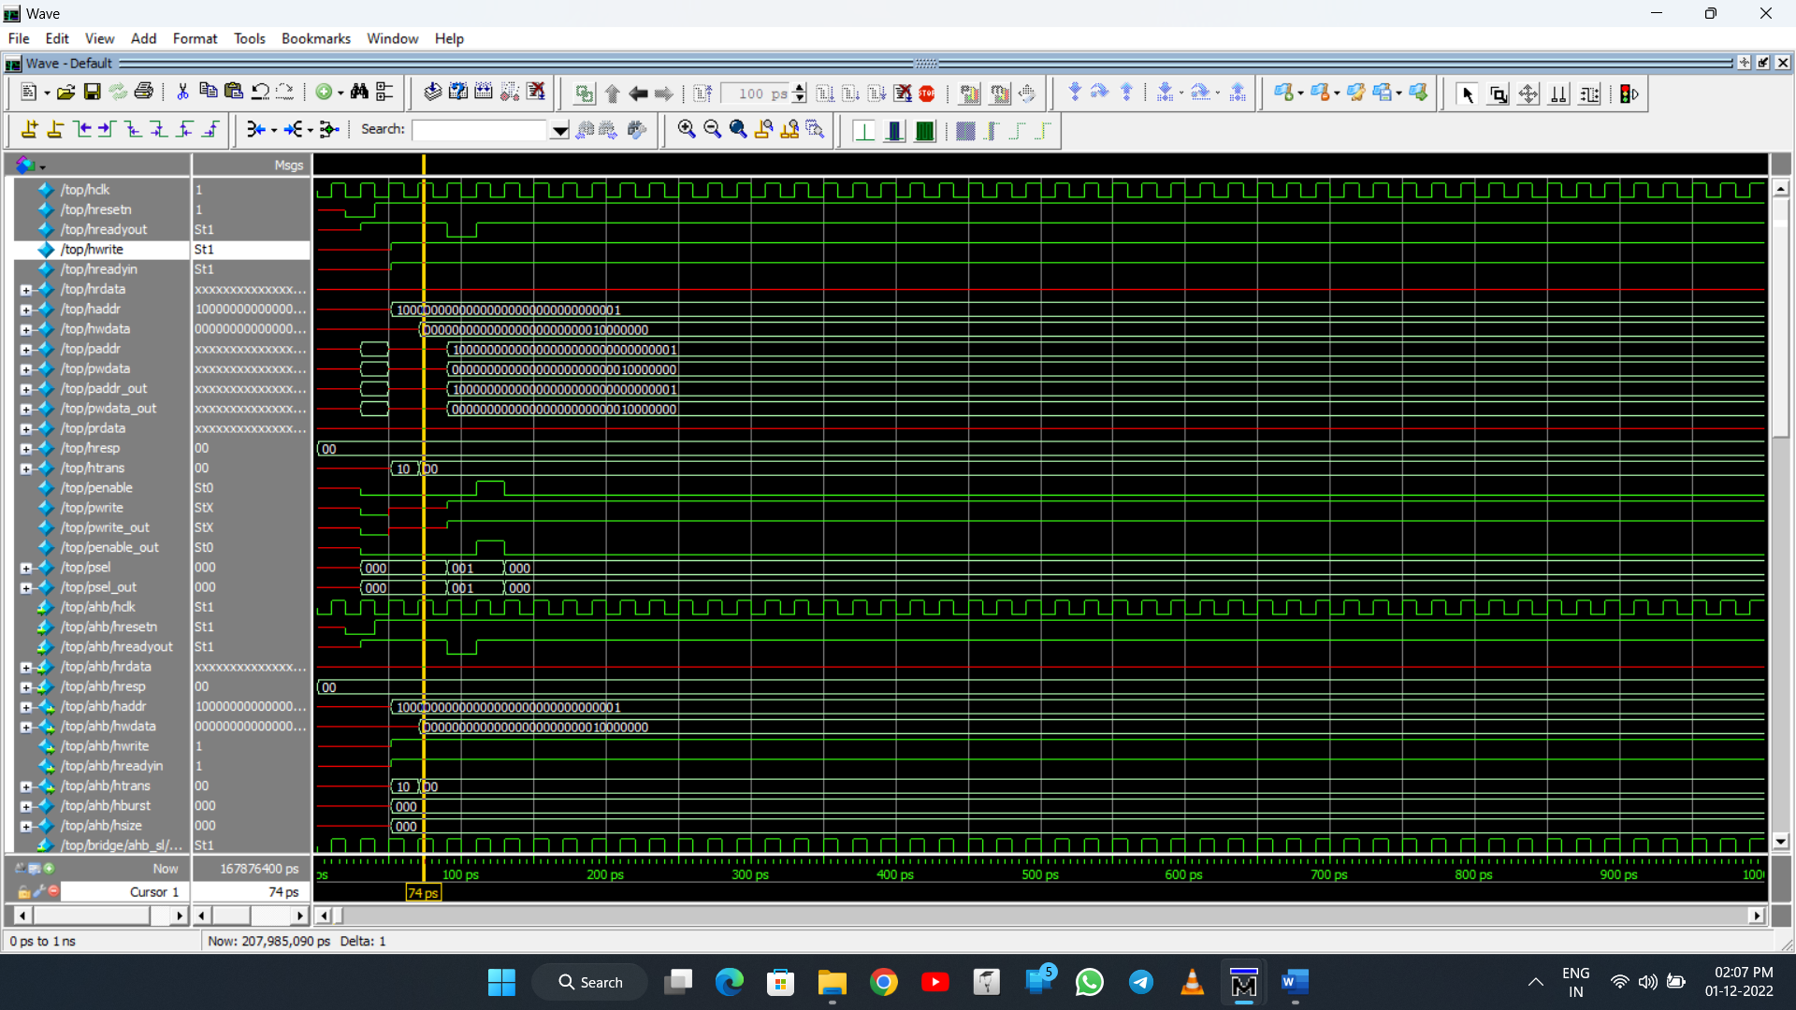

**SINGLE READ OPERATION**

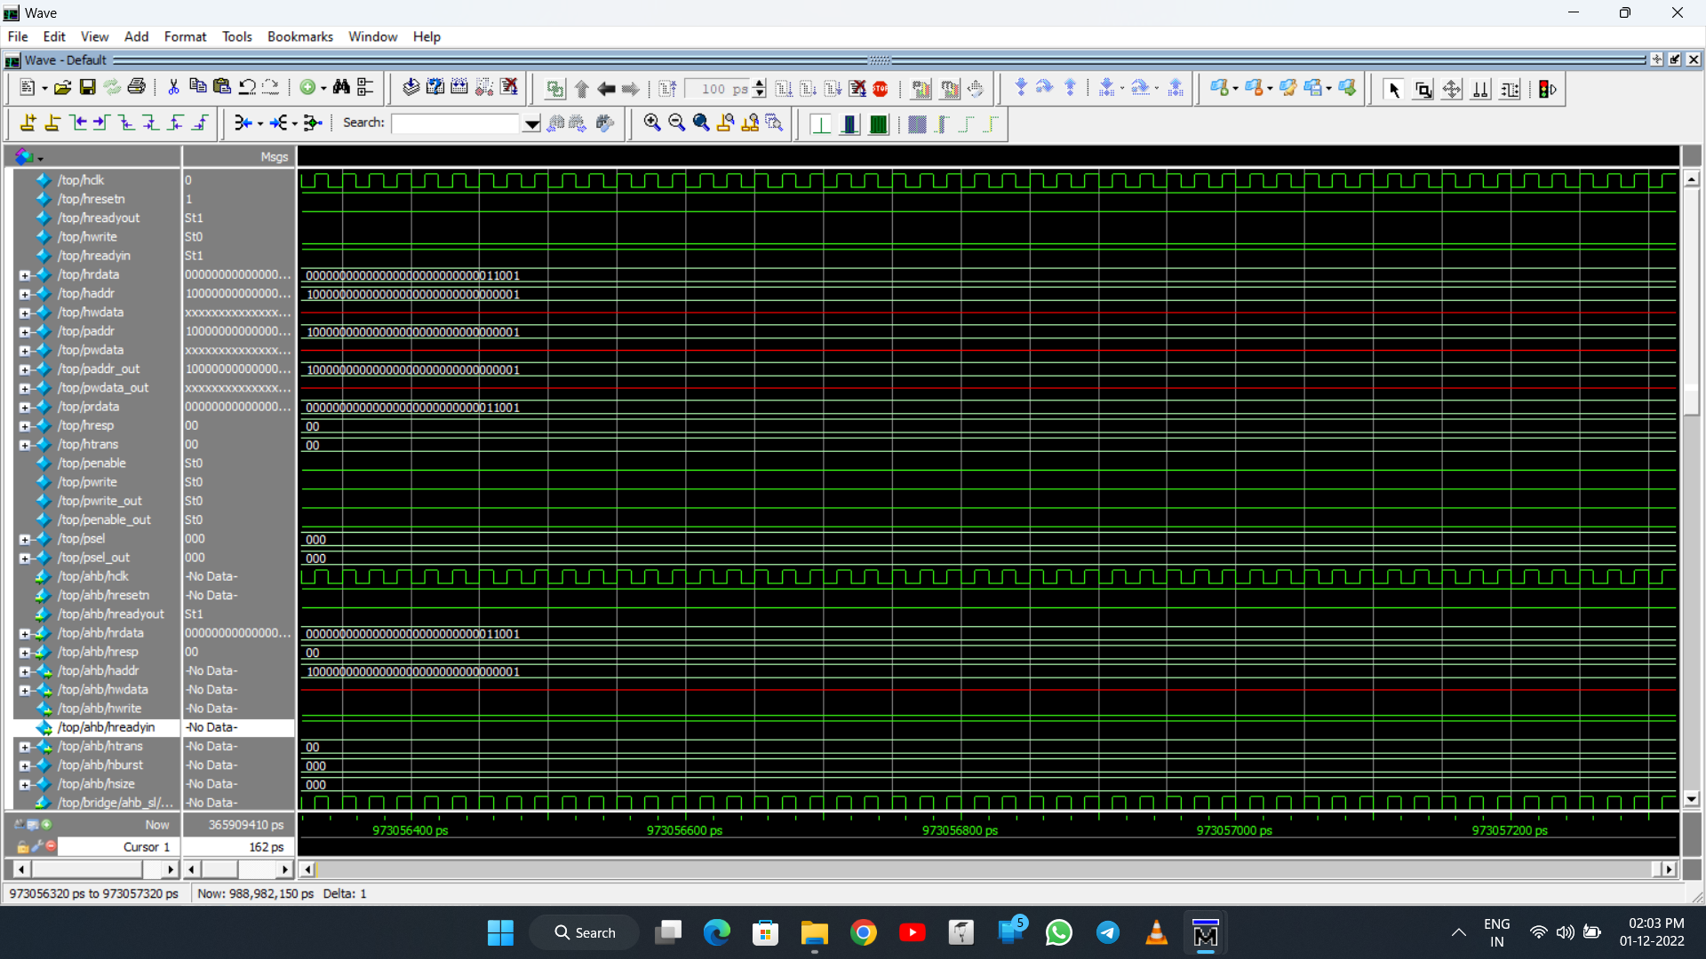

**AHB-APB BRIDGE INTERFACE ARCHITECTURE**

